**Introduction**:

In my previous project, I have worked as DevOps engineer primarily focussed on Azure DevOps and Kubernetes, where I was responsible for performing multi stage deployment of different application such as Java, Python, .Net.

In this role, I have deployed application using both the method, viz Using Azure DevOps Pipeline and traditional Kubernetes CLI. Also, I was responsible to ensure that the application is running smooth, and if we encounter any error such as "Crashloopbackoff Error" or others, we have to resolve the errors.

About the multi stage deployment I told earlier, so we were creating namespaces such as UAT, Dev, PreProd, Prod in the same kubernetes and were deploying there.

What are the different errors you faced.

We primarily faced "Crashloop Backoff" error, which occurs for multiple reason such as wrong image URL, Wrong tag in deployment file, or expiration of access key of ACR etc.

How you resolved the errors ?

If we are getting error in pipeline, then we have to go to Kubernetes server and perform manual deployment using the same deployment file, post which we have to analyze logs of pods, deployment, services to check where exactly where is the issue, post which based on logs we have to find and apply the solution.

kubectl apply -f deployment.yml

kubectl get all

kubectl describe pod PodName

kubectl descibe deployment DeployMentName

kubectl describe service ServiceName

What are the steps of CI/CD pipeline ?

Build Pipeline

Build

SCA (Static Code Analysis)--- SonarQube

Prepare code analysis

Run code analysis

push code analysis result

Docker build and push

Copy and publish to artifacts

Release Pipeline

Questions

1. What is the difference between build and release pipeline?
   1. First have to explain what is pipeline like pipeline is is continuous and automation task.
   2. Build pipeline contains three basic steps: code checkout, code build, packaging to generate artefact.

Release pipeline copies that artefact into agent and deploys it

1. How to deploy application using Azure App Services?
   1. using tasks, defining the inputs accordingly
2. what are auth methods available in Azure DevOps service connection?
   1. Id, pass and Token based
3. From Azure DevOps how do you access an application deployed on Azure?
   1. I said connect through an API is a solution
4. What about Terraform, how do you deploy a code written in Github?
   1. Terraform is IAAC we can create resources without using portal.

We can create multiple resources at a time.

We can reuse the existing scripts ,modules, variables.

To deploy code written in github so we need to choose the github repo while creating build pipeline and then add the tasks like terraform init,plan,apply.

* 1. Explaining the entire process -  package the code then run Terraform init, plan and apply auto approve.

1. How do you ensure that if multiple teams working on same project, deployment is mutually exclusive?

A .for different teams we can use different namespace in aks

* 1. Creating sub-folders and defining access to teams, also terraform state file manages exclusivity to some extent - explain

1. How can I see the pods running in K8S?
   1. kubectl get pods
2. What is the difference between daemonset and replicaset?

Kubernetes API is growing day by day and they are adding new features every day. The latest feature they added was DaemonSet.

Although they had ReplicaSet,  DaemonSet is the K8 object they added. Let’s see the difference.

ReplicasSet will ensure that the number of pods (defined in our config file) is always running in our cluster. Does not matter in which worker node they are running. The scheduler will schedule the pods on any node depending upon the free resources. If one of our nodes goes down then all pods running on the node will be randomly scheduled on different nodes as per the resource availability. In this way, ReplicaSet ensures that the number of pods of an application is running on the correct scale as specified in the conf file.

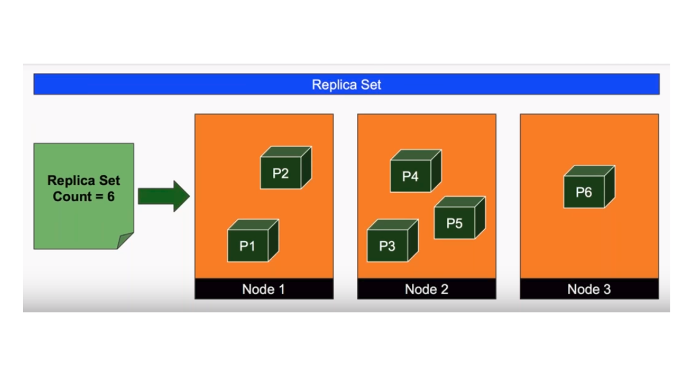

Whereas in the case of DaemonSet it will ensure that one copy of pod defined in our configuration will always be available on every worker node.

***The total # of pods running in DaemonSet = Number of worker nodes in our cluster***

If a new node is added in our cluster then DaemonSet will automatically allocate pod on that node. Similarly, if a node is deleted then the pod running on the node is also destroyed, it will not reschedule the pod on different nodes as in case of ReplicaSet.

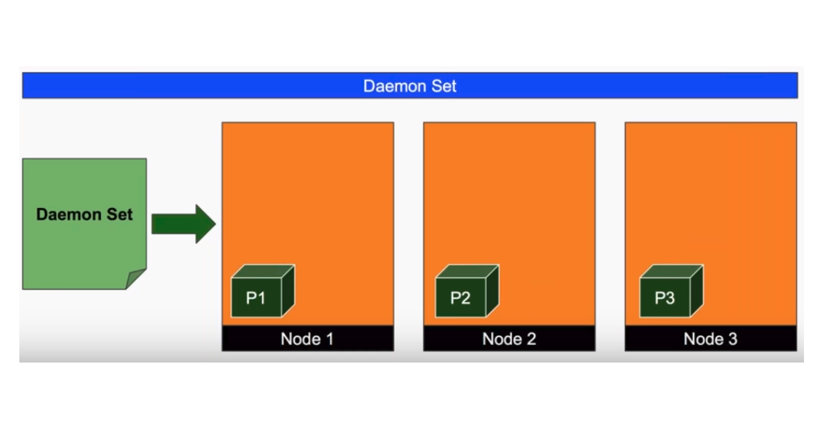

Let’s take a scenario where we have to create a pod containing nginx image in it. Below are the configuration files for creating a ReplicaSet and DaemonSet. Save this configuration in ***DemonSet.yml***file.

|  |  |
| --- | --- |
|  | apiVersion: extensions/v1beta1 |
|  | kind: DaemonSet |
|  | metadata: |
|  | labels: |
|  | app: nginx |
|  | name: example-daemon |
|  | spec: |
|  | template: |
|  | metadata: |
|  | labels: |
|  | app: nginx |
|  | spec: |
|  | containers: |
|  | – name: nginx |
|  | image: nginx |

[view raw](https://gist.github.com/sachin-slathia/ffd7796865720df2e57498a4e3058155/raw/d381320aaa174253a2eeae92947d071552c3d111/gistfile1.txt)[gistfile1.txt](https://gist.github.com/sachin-slathia/ffd7796865720df2e57498a4e3058155#file-gistfile1-txt)hosted with  by [GitHub](https://github.com/)

This is the configuration of a DaemonSet for nginx.

To create the Deamon Set, execute below commands.

***kubectl create -f DemonSet.yml***

This daemonSet will create a pod in every node running in our cluster.

The configuration of ReplicaSet:-

|  |  |
| --- | --- |
|  | apiVersion: apps/v1 |
|  | kind: ReplicaSet |
|  | metadata: |
|  | labels: |
|  | app: nginx |
|  | name: example-daemon |
|  | spec: |
|  | replicas: 3 |
|  | selector: |
|  | matchLabels: |
|  | app: nginx |
|  | template: |
|  | metadata: |
|  | labels: |
|  | app: nginx |
|  | spec: |
|  | containers: |
|  | – name: nginx |
|  | image: nginx |

[view raw](https://gist.github.com/sachin-slathia/866f9e24997f59a724d281143c0005ac/raw/c84143520f6cd744ffefc064ef4a2aa97b803d5a/gistfile1.txt)[gistfile1.txt](https://gist.github.com/sachin-slathia/866f9e24997f59a724d281143c0005ac#file-gistfile1-txt)hosted with  by [GitHub](https://github.com/)

This ReplicaSet will make sure that 3 replicas are present in our cluster everytime whether our node is up or down. The scheduler will take care on which node to schedule pod depending upon the free resources on the node.

Hope this blog was helpful in seeing the difference between DaemonSet and ReplicaSet.

1. Explain components of K8S cluster
   1. etcd, controller, API, scheduler etc.
2. how cluster IP is different from node IP
   1. I said node IP is not exposed outside cluster
3. Kubernetes networking - said little exposure
4. explain K8S volume and attachment - explained
5. My K8S cluster volume should not die, how is it possible?
   1. I said pvc
6. How to attach pvc?
   1. Azure storage account should be used as the volume (pvc)
7. How you attach extra volume without zero downtime in clusters?
   1. I explained towards route 53 concept, but he expects simpler, maybe extending replicaset etc.
8. How to secure deployed app service in Azure?
   1. Explained the concept of public and private subnets, and bastion server, configuring ingress to filter incoming traffic - all concepts

He said also using firewall, gateway etc. can be achieved. I said there are multiple ways to achieve security, i explained what I used

in my project.

1. 16. Any idea about MQ?
   1. I said AWS SQS. He said Azure counterpart is Service Bus